**DSA Practice 4 (13-11-24)**

**By Jashwanth SA**

**CSE-C (22CS066)**

1. **Kth smallest:**

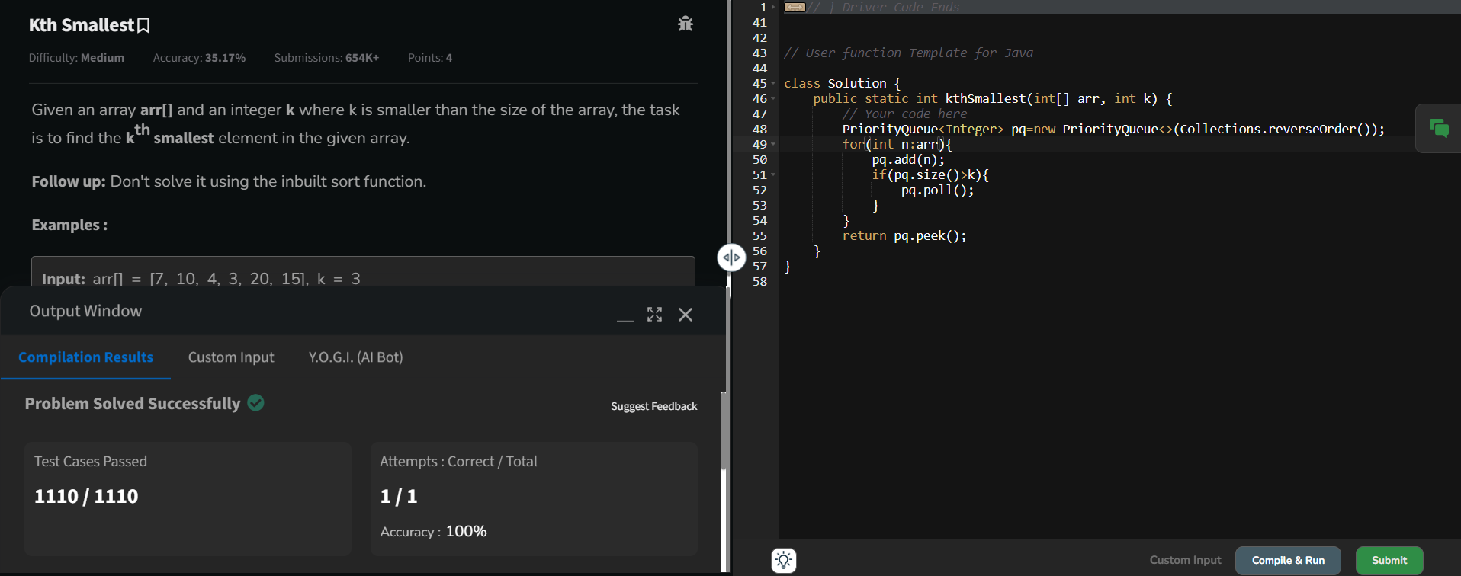

Time complexity: O(n)

1. **Minimize the heights 2:**

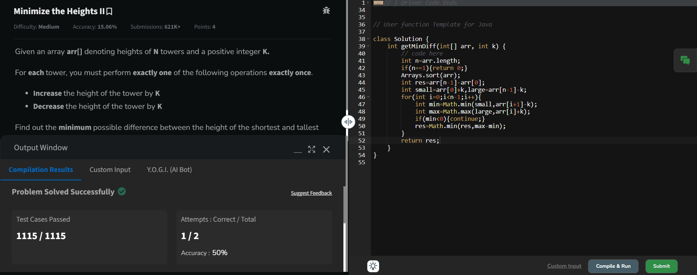

Time complexity: O(n logn)

1. **Parantheses checker:**

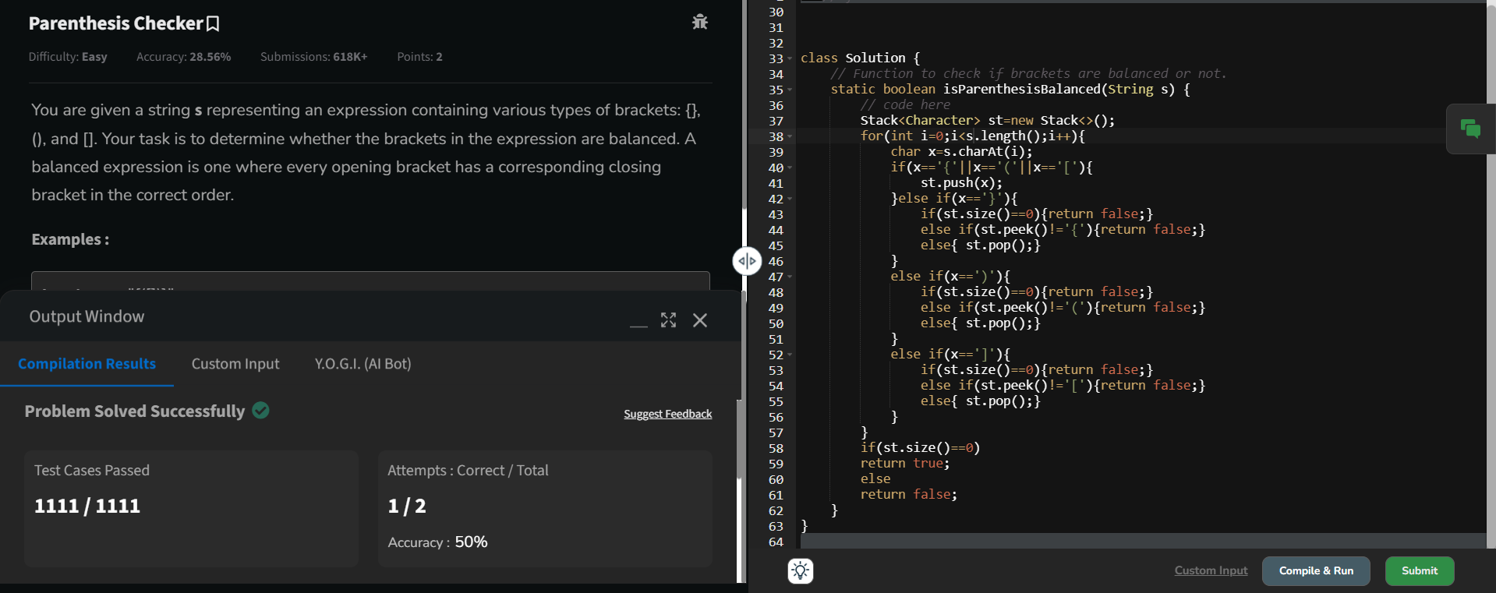

Time complexity: O(n)

1. **Equilibrium point:**

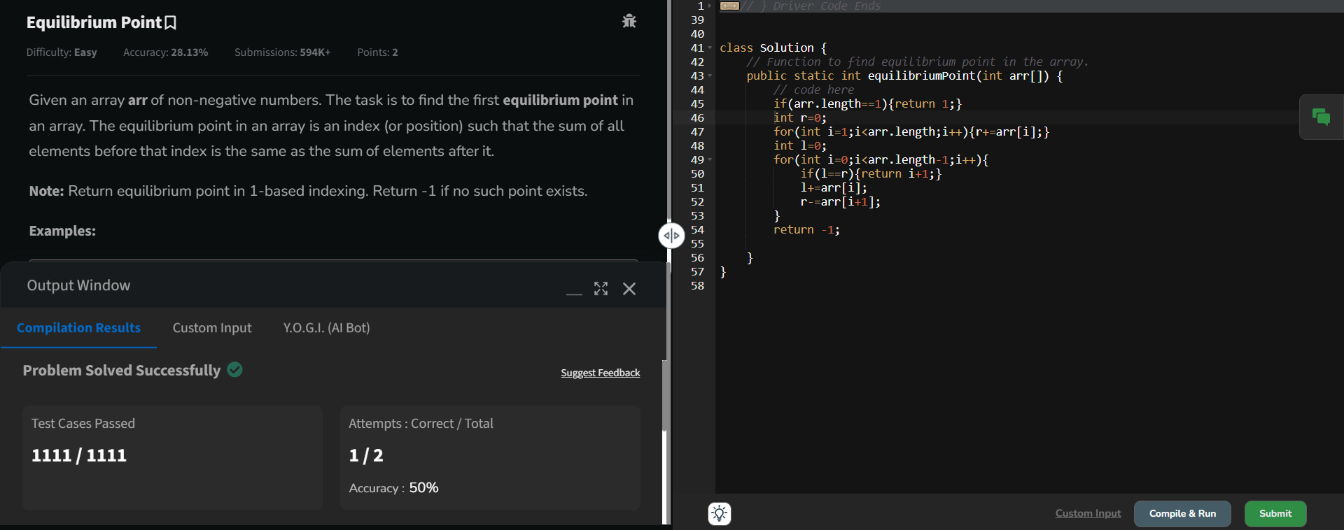

Time complexity: O(n)

1. **Binary search:**

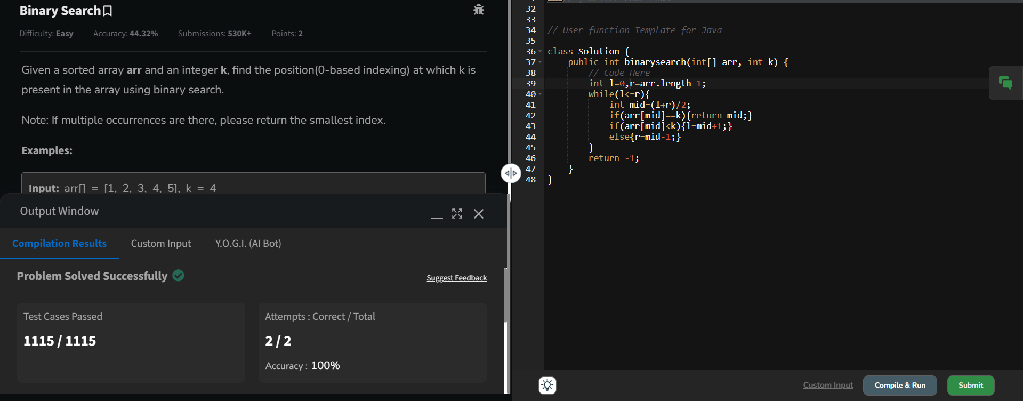

Time complexity: O(logn)

1. **Next Greater Element:**

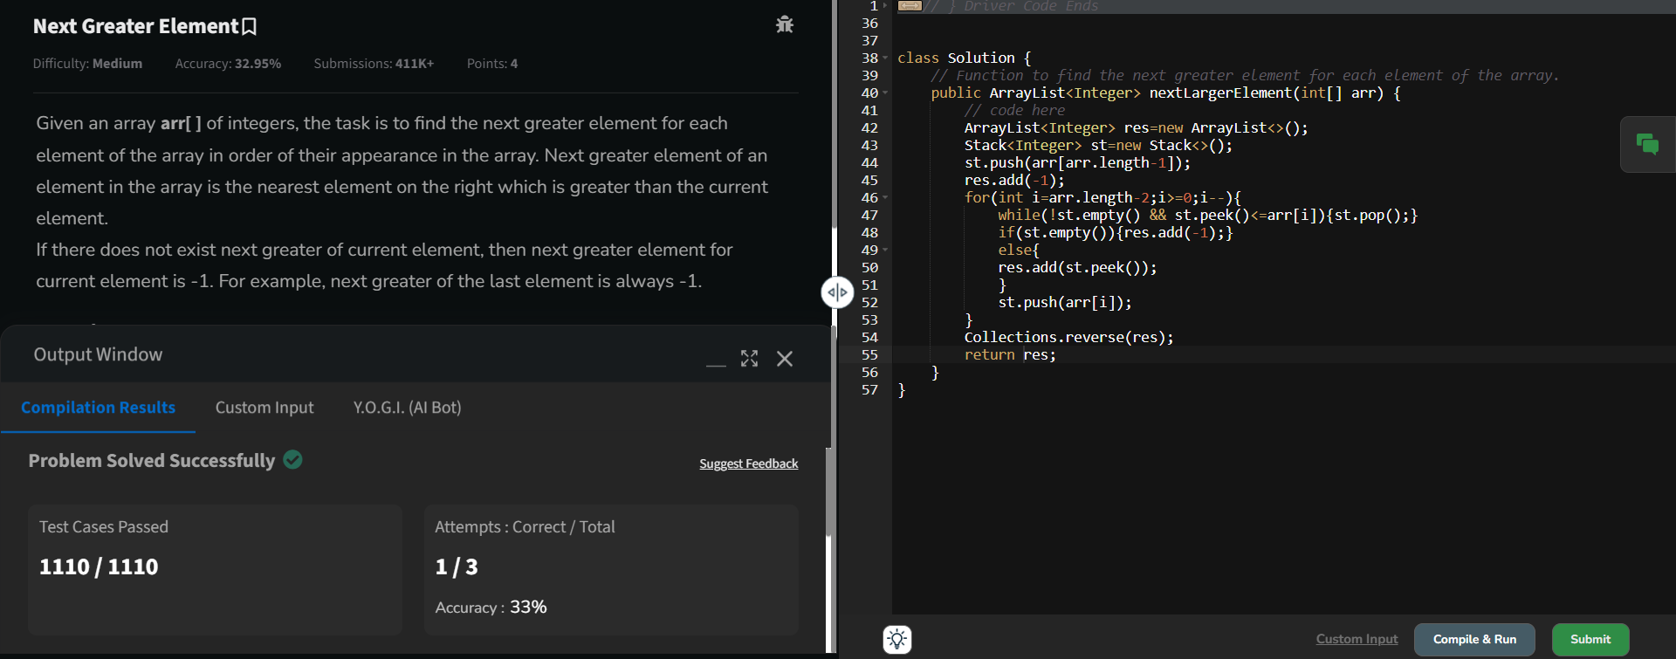

Time complexity: O(n)

1. **Union of 2 arrays with duplicate elements:**

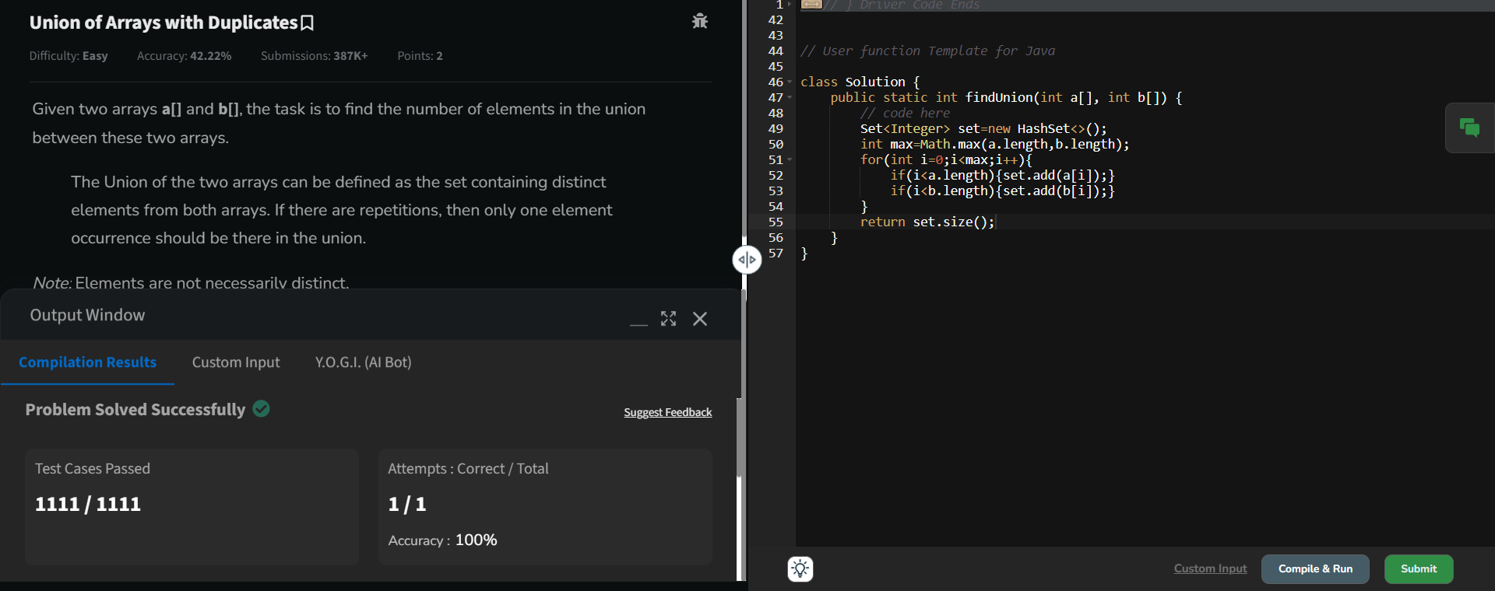

Time complexity: O(n)